OpenVPN Client on Mikrotik Router

Con Ubuntu 18.04 64bits Para Conectar SmartISP by API

Prepared By

Rodrigo Anrrango
Network Specialist and Consultant
https://SmartISP.us/install

Contents

Introduction 3
Network Topology 3
Devices 3
OpenVPN Server 3
Mikrotik 3
Server Configurations 3
Mikrotik Configurations 8
Accessing Client LAN 11
Reserve Static IPs for clients 13
Troubleshooting 14
Useful Links 15

Introduction

The goal of this project is to configure an Ubuntu OpenVPN server and a Mikrotik OpenVPN client.

Network Topology

In this project we are using the following topology:

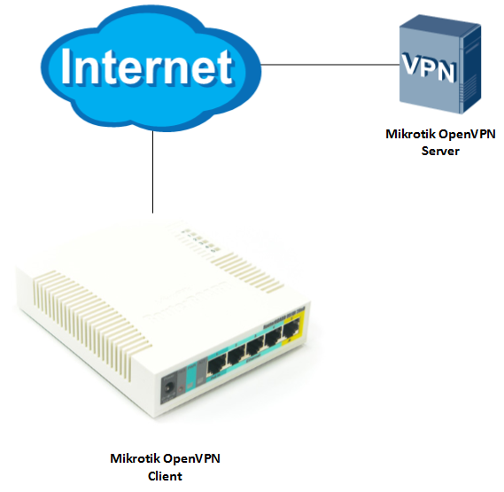

Devices

OpenVPN Server
A VPS server with Ubuntu 18.04.2 LTS.

Mikrotik
A Mikrotik RB951Ui-2HnD router as OpenVPN client.

Server Configurations

Run the following commands as root:

Step 1: Install OpenVPN

apt-get update
apt-get install openvpn easy-rsa

Step 2: Setup CA

make-cadir certificates && cd certificates

Step 3: Configure the CA Variables

nano vars

Set the following according to your requirement:
export KEY_COUNTRY="US"
export KEY_PROVINCE="NY"
export KEY_CITY="New York City"
export KEY_ORG="DigitalOcean"
export KEY_EMAIL="admin@example.com"
export KEY_OU="Community"

(Only edit the values in red)
Change:
export KEY_CONFIG=`$EASY_RSA/whichopensslcnf $EASY_RSA`

To:
export KEY_CONFIG="$EASY_RSA/openssl-1.0.0.cnf"

Save and close the file.

source vars

Step 4: Build the Certificate Authority

./clean-all && ./build-ca

Press Enter through all the prompts.

Step 5: Create the Server Certificate, Key, and Encryption Files

./build-key-server server

Accept the default values by pressing ENTER. Do not enter a challenge password for this setup. Towards the end, you will have to enter y to two questions to sign and commit the certificate.
./build-dh
openvpn --genkey --secret keys/ta.key

Step 6: Client Setup

source vars && ./build-key client

Step 7: Configure the OpenVPN Service

cp keys/{server.crt,server.key,ca.crt,dh2048.pem,ta.key} /etc/openvpn
gunzip -c /usr/share/doc/openvpn/examples/sample-config-files/server.conf.gz | tee /etc/openvpn/server.conf

Adjust the OpenVPN Configuration:
nano /etc/openvpn/server.conf

Set the following:
cipher AES-128-CBC

Change protocol from UDP to TCP:
proto tcp
;proto udp

LZO Compression should be disabled:
;comp-lzo

Uncomment duplicate common name setting (this allows multiple clients to connect to the server using the same certificate):
duplicate-cn

Comment this setting (otherwise it produces HMAC errors):
;tls-auth ta.key 0

Comment this setting (not compatible with TCP):
;explicit-exit-notify 1
Save and close the file

Step 8: Adjust the Server Networking Configuration

nano /etc/sysctl.conf
Allow IP Forwarding:
# Uncomment:
net.ipv4.ip_forward=1
Save and close the file.

Aplicar:
sysctl -w net.ipv4.ip_forward=1
Adjust the UFW Rules to Masquerade Client Connections:

nano /etc/ufw/before.rules
Add the part in red (replace eth0 with your actual interface):

#
# rules.before
#
# Rules that should be run before the ufw command line added rules. Custom
# rules should be added to one of these chains:
# ufw-before-input
# ufw-before-output
# ufw-before-forward
#

# START OPENVPN RULES
# NAT table rules
*nat
:POSTROUTING ACCEPT [0:0]
# Allow traffic from OpenVPN client to eth0
-A POSTROUTING -s 10.8.0.0/8 -o eth0 -j MASQUERADE
COMMIT
# END OPENVPN RULES

# Don't delete these required lines, otherwise there will be errors
*filter
. . .

Save and close the file.

nano /etc/default/ufw
Change the value from DROP to ACCEPT:

DEFAULT_FORWARD_POLICY="ACCEPT"

Save and close the file.

Open the OpenVPN Port and Enable the Changes:

ufw allow 1194
ufw allow OpenSSH
ufw disable
ufw enable

Step 9: Start and Enable the OpenVPN Service

systemctl start openvpn@server
systemctl status openvpn@server

The status should be active (running).
systemctl enable openvpn@server

Step 10: Generate Additional Client Configurations

To generate configuration files for additional clients, enter the following commands:
cd certificates
source vars && ./build-key client1
RBs 2
source vars && ./build-key client2

This will generate all configuration files for client1 which may be downloaded from /root/certificates/keys/ directory.

Step 11: Mikrotik Configurations

Step 1: Copy Certificates and Keys
Go to /etc/openvpn/ directory on OpenVPN server and download this file to your local computer:
ca.crt

Go to /root/certificates/keys/ directory and download these file as well:
client1.crt client1.key
Open Mikrtok router using Winbox and drag and drop these files:
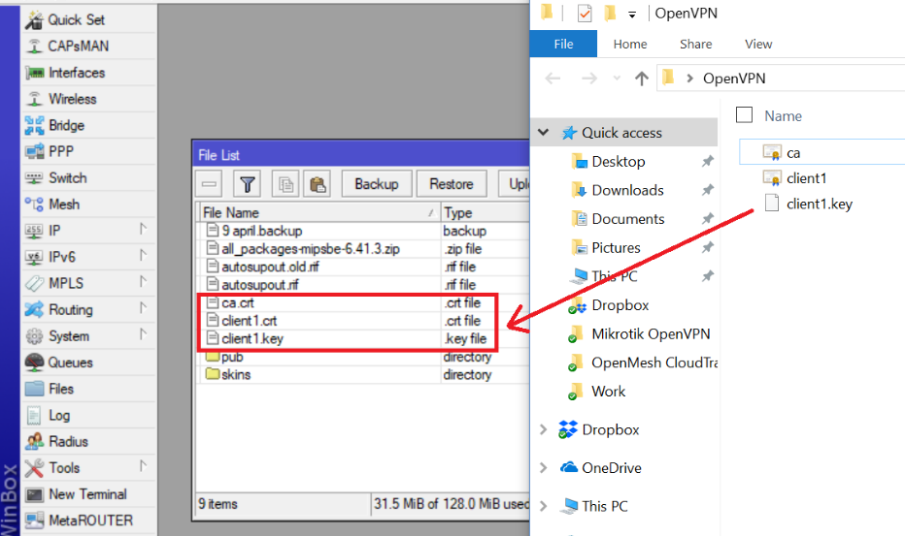

Step 2: Installing Certificates
Go to System -> Certificates and import ca.crt: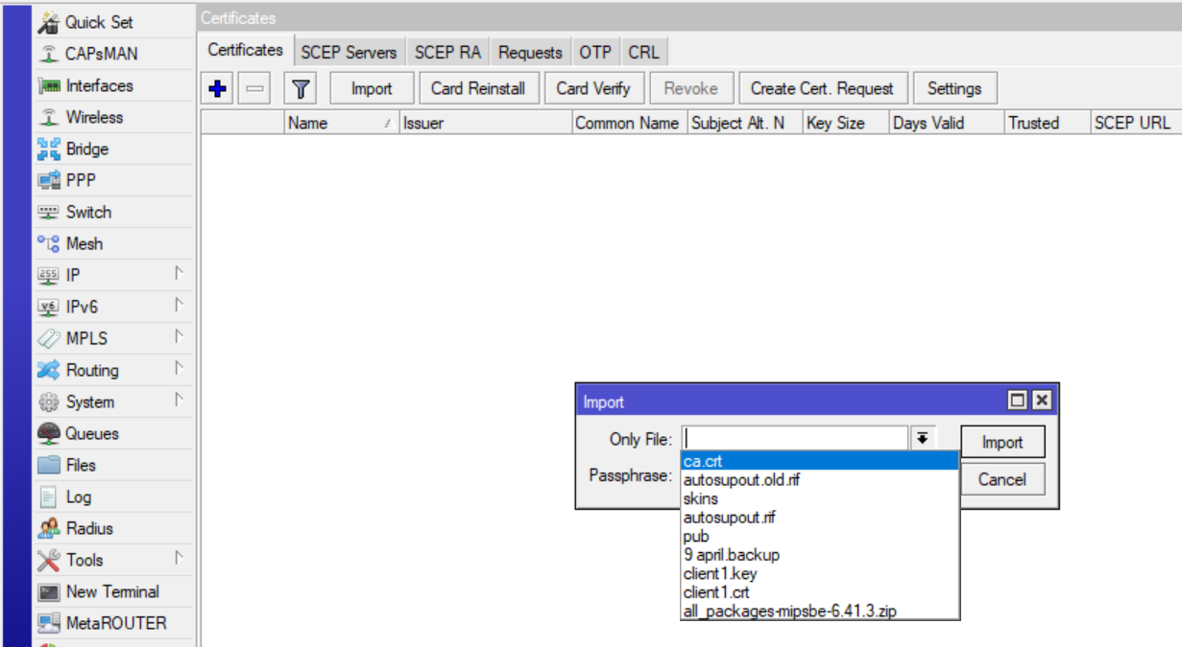

Similarly import client1.crt and client1.key.
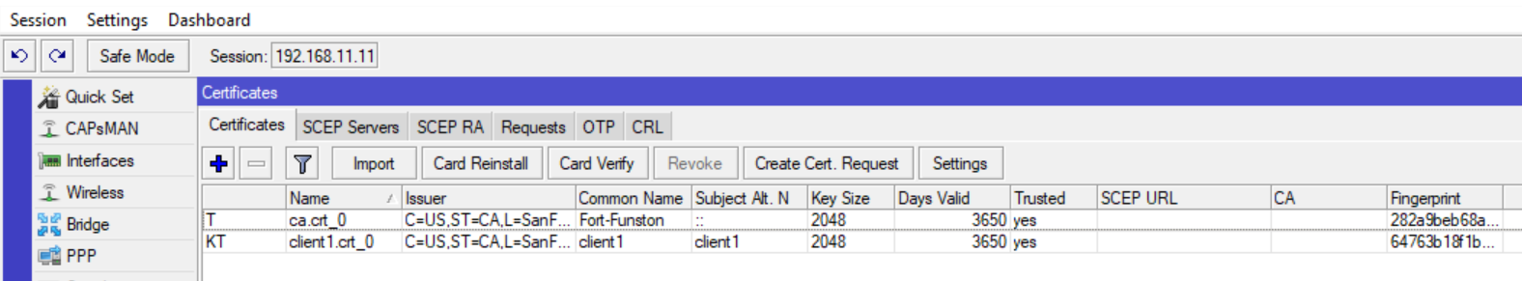

Step 3: Create a PPP Profile
Go to PPP -> Profiles and create a new profile. Give it a name of your choice. Go to Protocols and disable MPLS and IPv6. “Use Encryption” option should be set to “required”. Go to Limits tab and set Only One to “yes”. Save this profile.

Step 4: Create an OVPN Client Connection
Go to PPP -> Interface and add a new “OVPN Client” interface. Give it a name of your choice. Go to “Dial Out” tab and set the following properties:
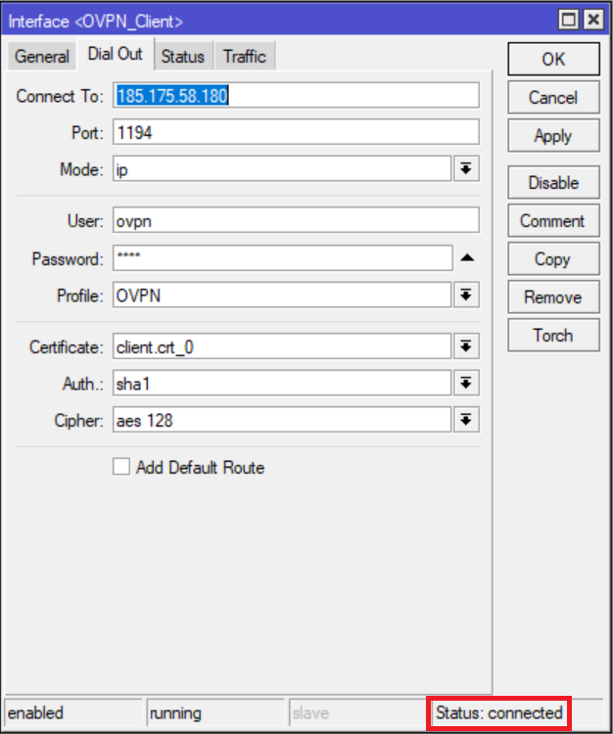
The username and password can be anything. However, it is mandatory and cannot be blank. If everything went well your VPN should be connected.

Reserve Static IPs for clients OpenVPN

First allow client-config option in OpenVPN config file:
nano /etc/openvpn/server.conf

Go to the following line:
;client-config-dir ccd

Uncomment it and change it to:
client-config-dir ccd
Save and exit the file.

Enter the following commands:

mkdir /etc/openvpn/ccd
touch /etc/openvpn/ccd/client1

Create a CCD file for the client. The filename should be the same as the client name:

nano /etc/openvpn/ccd/client1
ifconfig-push 10.8.0.254 10.8.0.1

Save and close the file. These settings will make sure that client1 is always assigned the IP address 10.8.0.254 upon connection with gateway IP 10.8.0.1.

Next step is to reserve this IP in the ifconfig-pool-persist file. Enter the following commands:

nano /etc/openvpn/ipp.txt
client1,10.8.0.254

Save and close the file and restart the OpenVPN service:

systemctl restart openvpn.service

Troubleshooting

To troubleshoot you can go to OpenVPN server and run the following command to see Syslogs related to OpenVPN:
tailf /var/log/syslog | grep vpn
Any errors encountered during connection will be displayed here.

Useful Links

https://linuxconfig.org/openvpn-setup-on-ubuntu-18-04-bionic-beaver-linux
https://github.com/missinglink/mikrotik-openvpn-client

